Network Project Documentation

1. Full topology + successful ping between networks

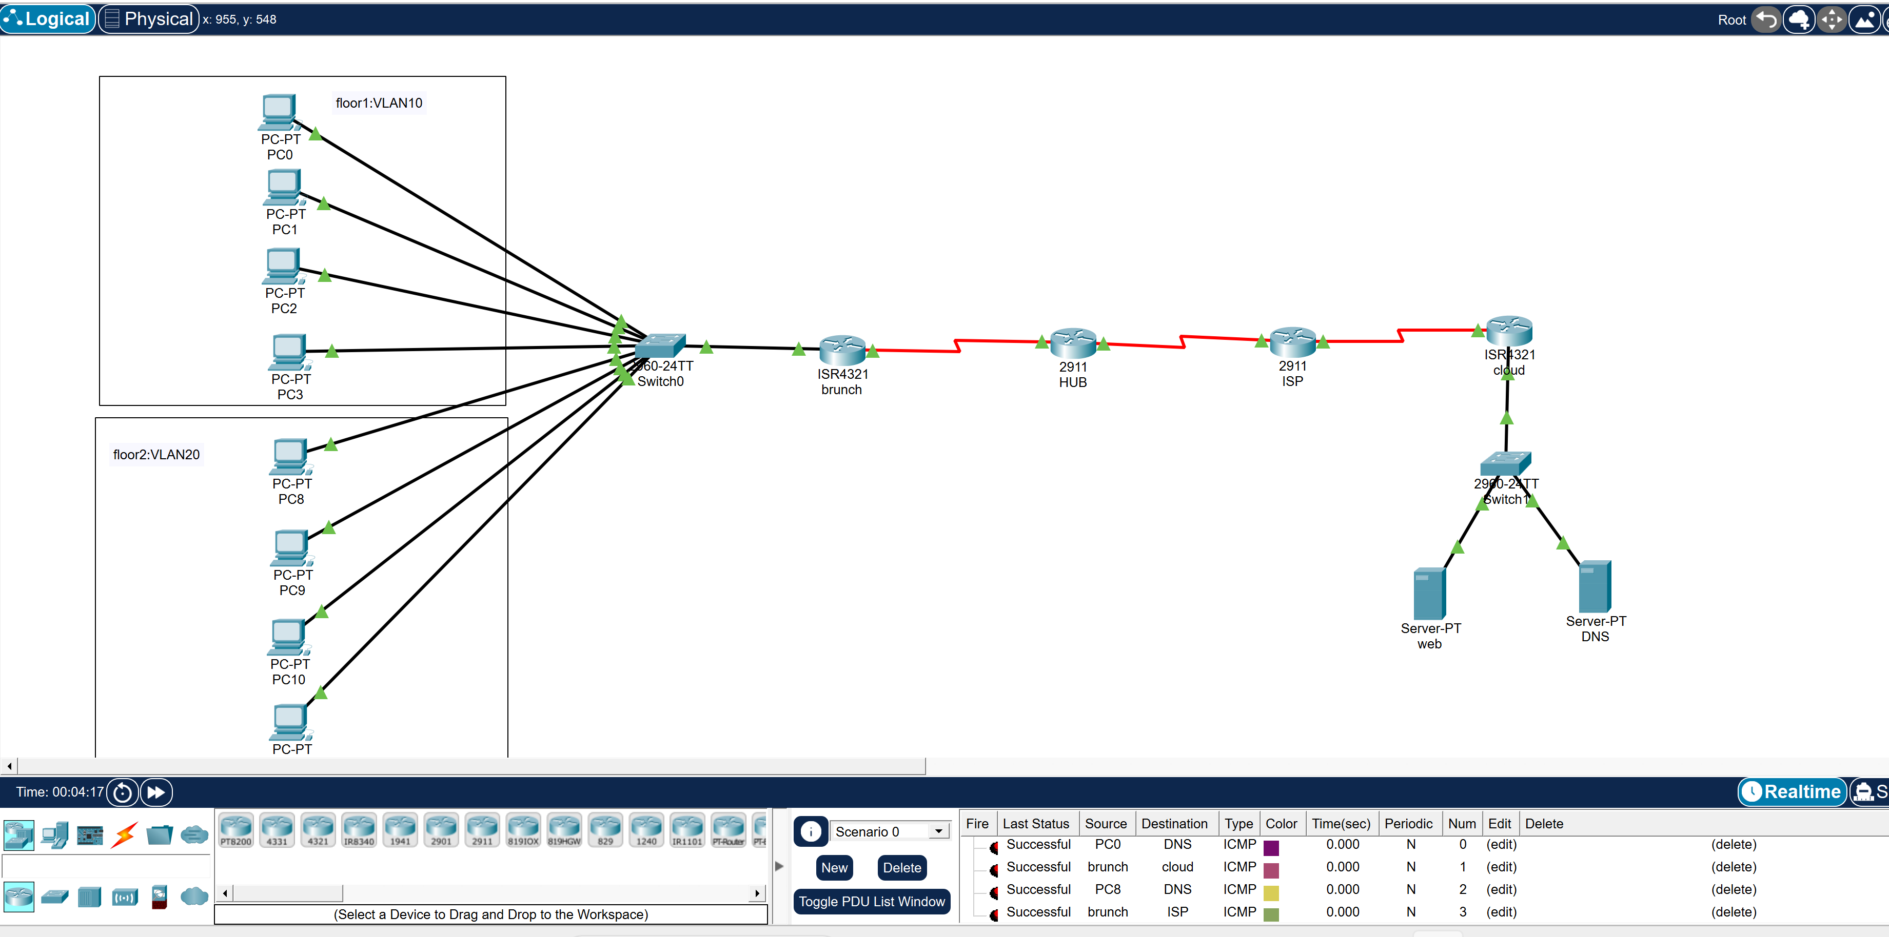

IP Mapping
Private:
VLAN10: 192.168.1.0/25
VLAN20: 192.168.1.128/26
Servers: 10.10.10.0/24
Public:
WAN links: 200.0.0.0/30 networks
NAT IP:200.0.0.100(outside)<-> 10.10.10.2(inside)

Devices & Connections
Routers: Cisco 2911 and Cisco4321
Switches: Cisco 2960
Cables:
PC-Switch: Straight
Switch-Router: Straight
Router-Router: Serial

Protocols
DHCP: Branch Router
NAT: Cloud Router (Static NAT)
VPN: Branch to Cloud
Routing: Static routing across all routers
DNS: Cloud server

2. VLSM calculation table

Subnet | Mask | First IP | Last IP | Broadcast | Description
192.168.1.0 | 255.255.255.128 | 192.168.1.1 | 192.168.1.126 | 192.168.1.127 | floor1
192.168.1.128 | 255.255.255.192 | 192.168.1.129 | 192.168.1.190 | 192.168.1.191 | floor2
200.0.0.0 | 255.255.255.252 | 200.0.0.1 | 200.0.0.2 | 200.0.0.3 | BR-hup
200.0.0.4 | 255.255.255.252 | 200.0.0.5 | 200.0.0.6 | 200.0.0.7 | hup-ISP
200.0.0.8 | 255.255.255.252 | 200.0.0.9 | 200.0.0.10 | 200.0.0.11 | ISP-cloud
10.10.10.0 | 255.255.255.0 | 10.10.10.1 | 10.10.10.254 | 10.10.10.255 | servers

3. Router IP configurations:
Branch
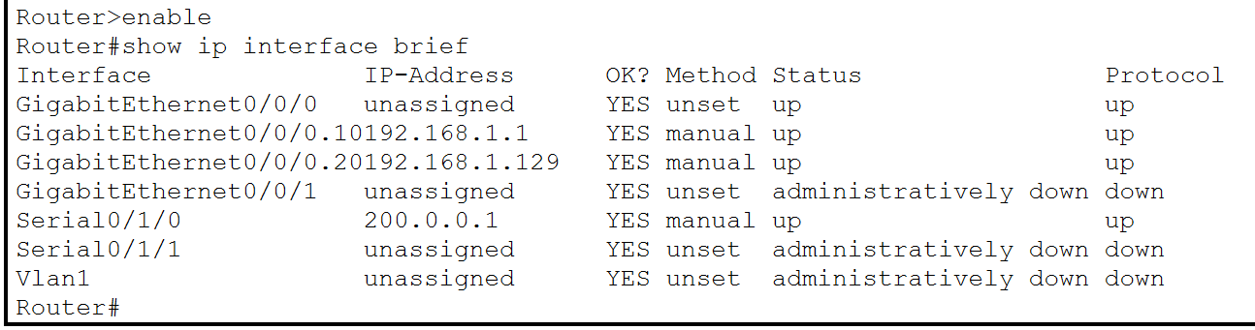
RH hup :
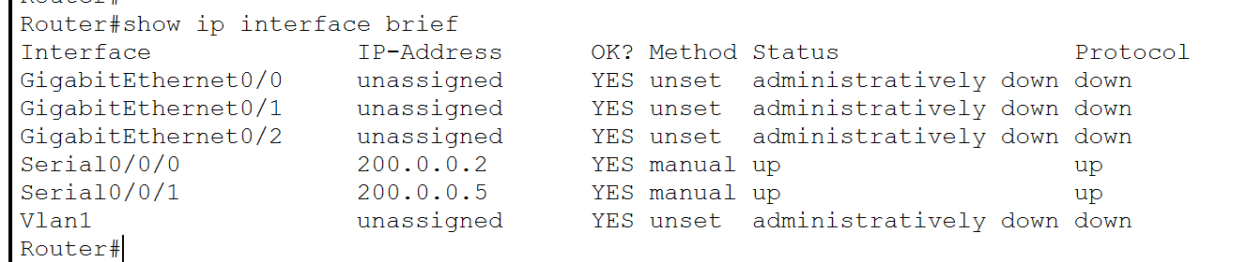

ISP:
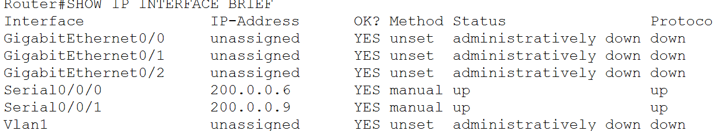

CLOUD:
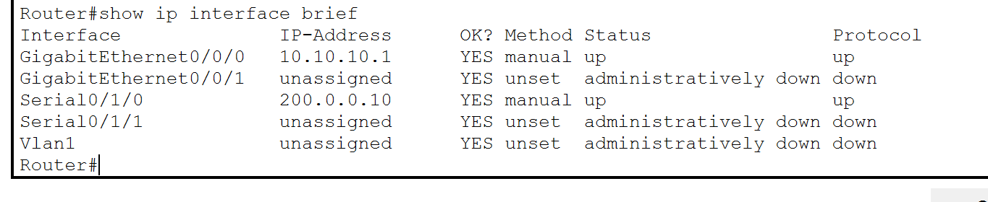

4. DHCP + sample PC IP settings:
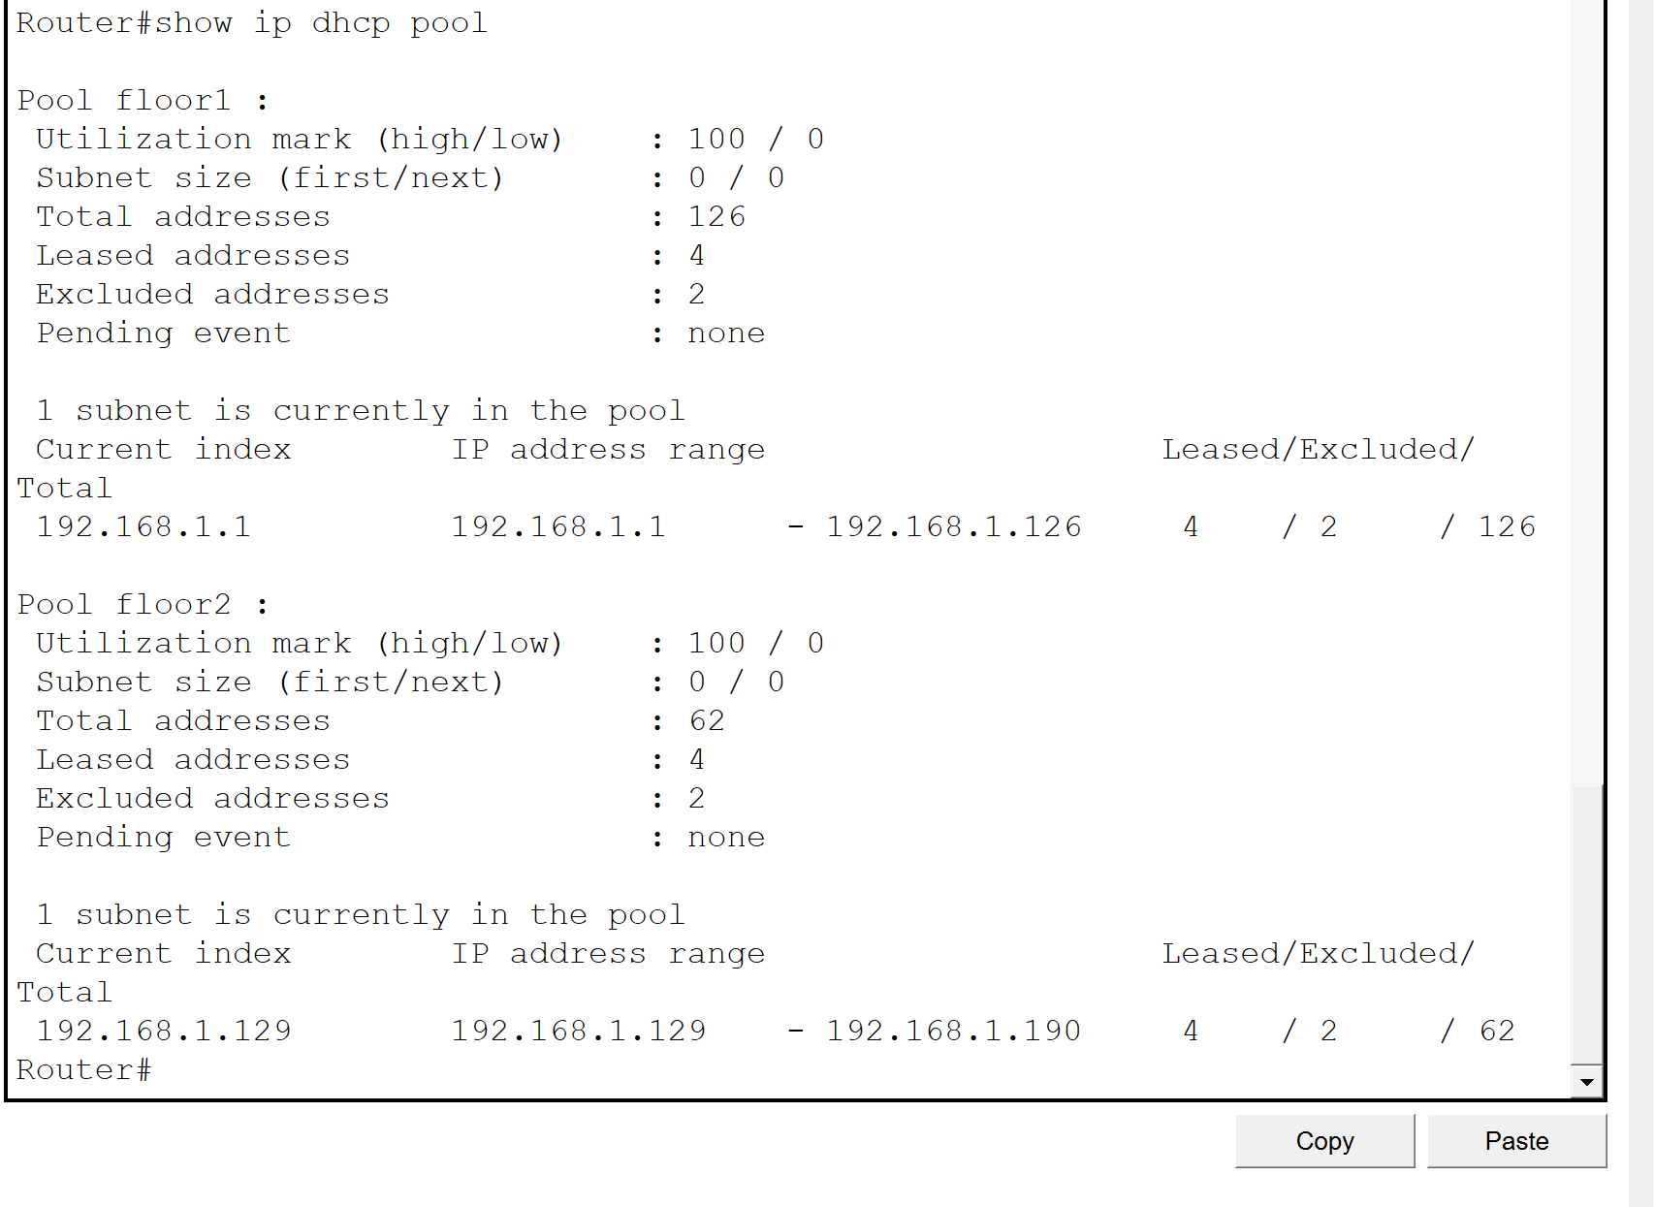

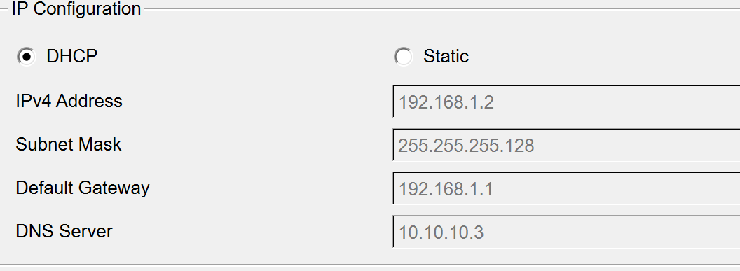

5. Browser accessing website using domain

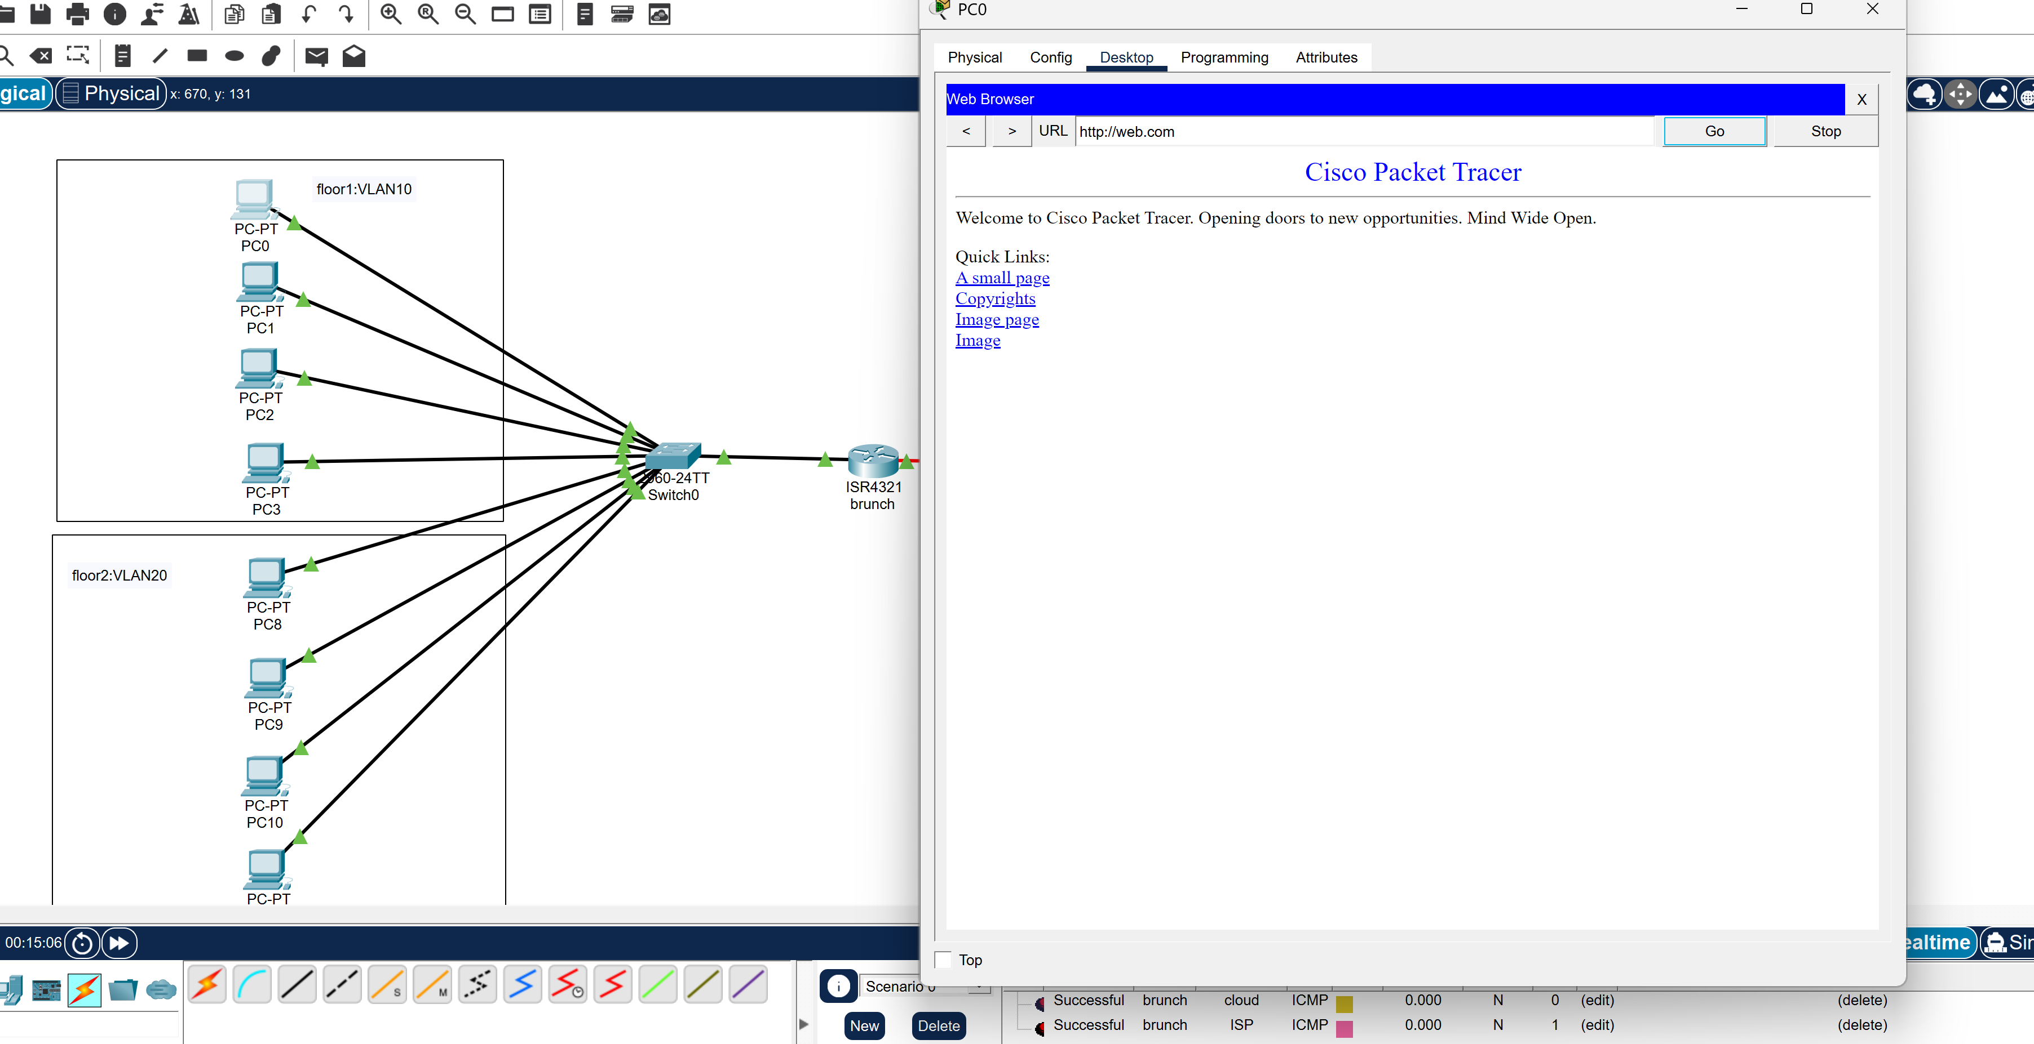
Ping between branch and cloud:
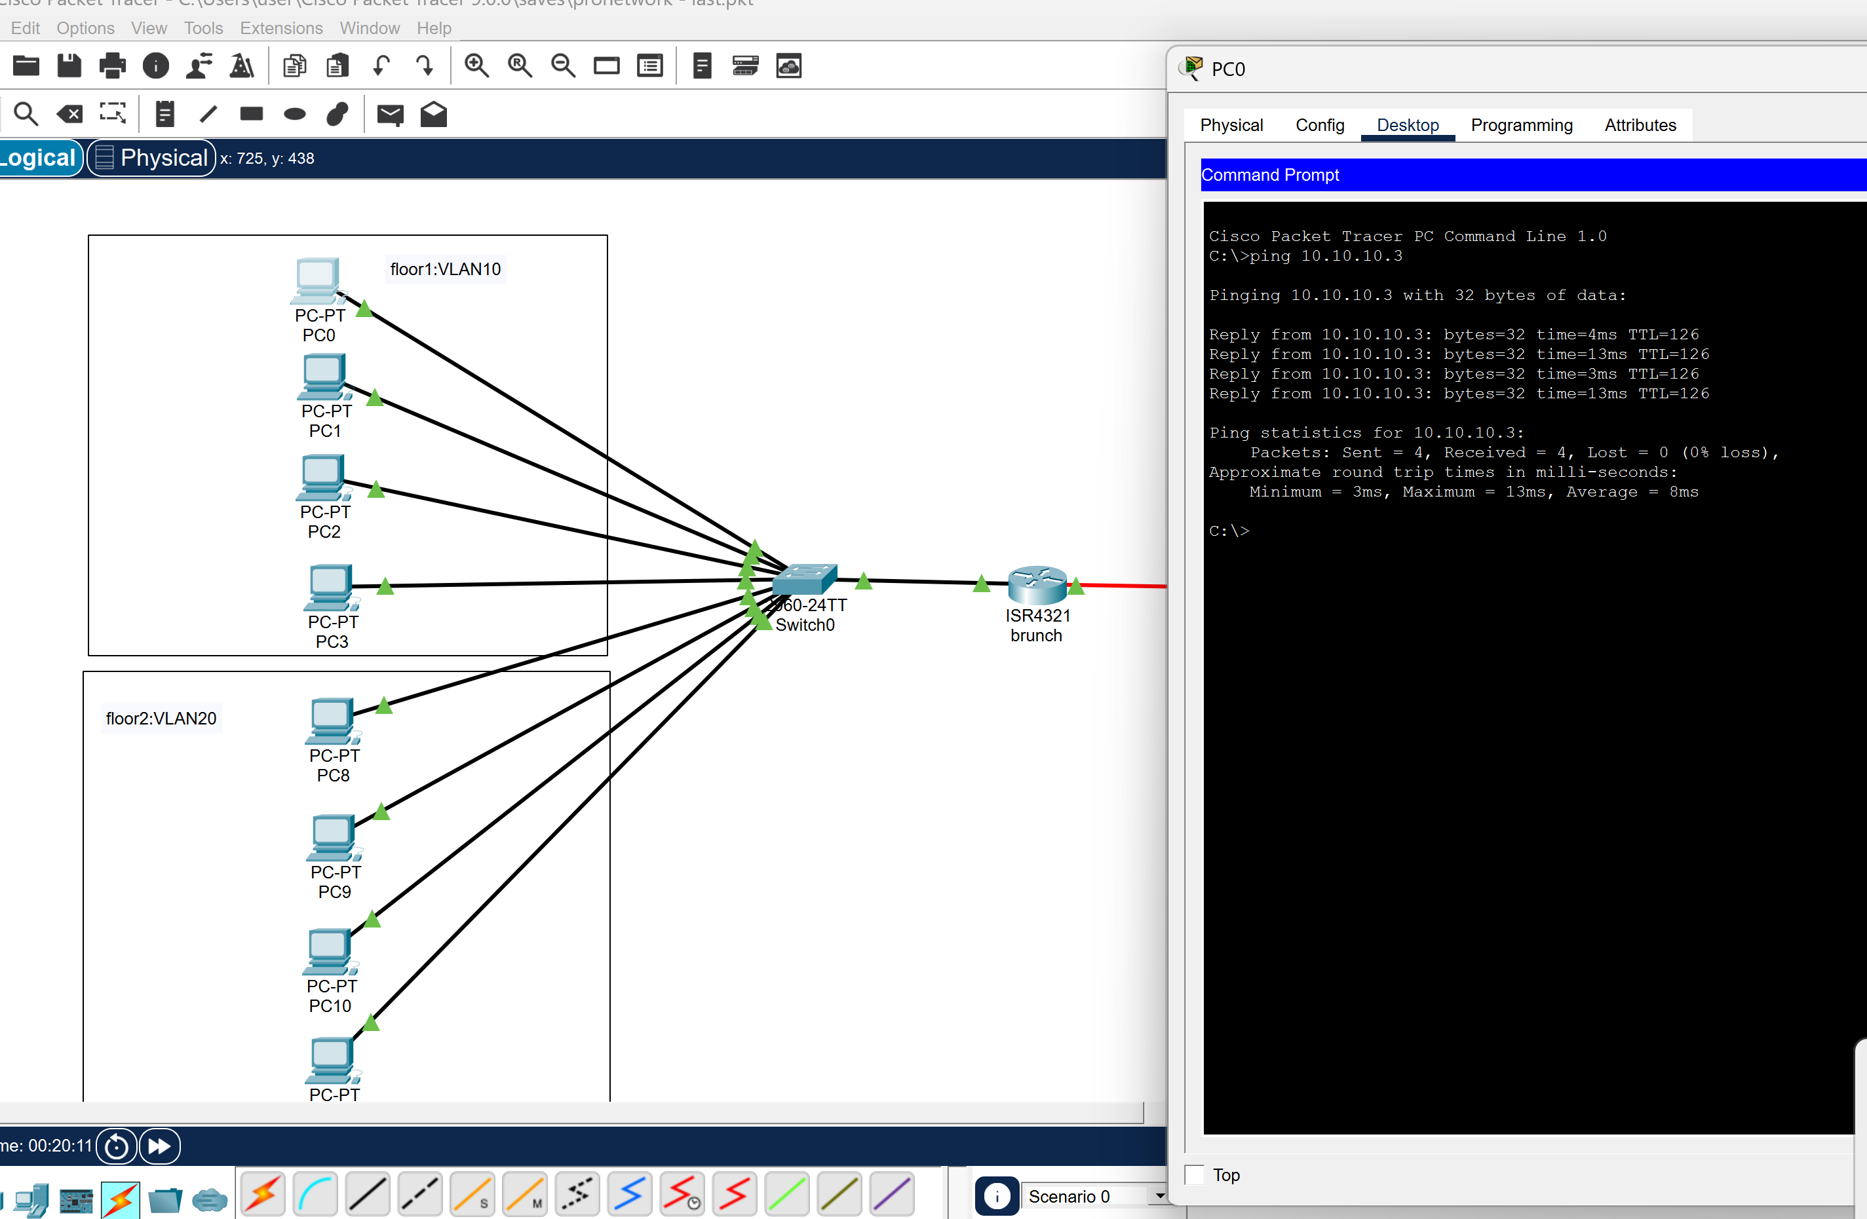

6. VLAN table

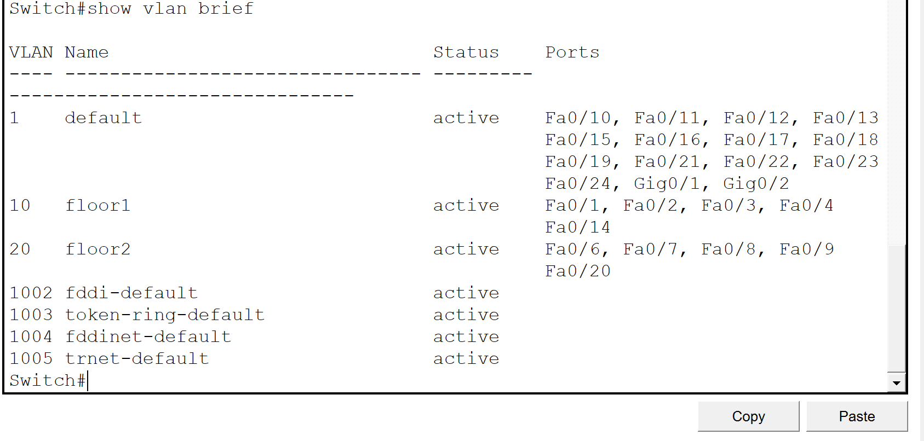

7. NAT translation table

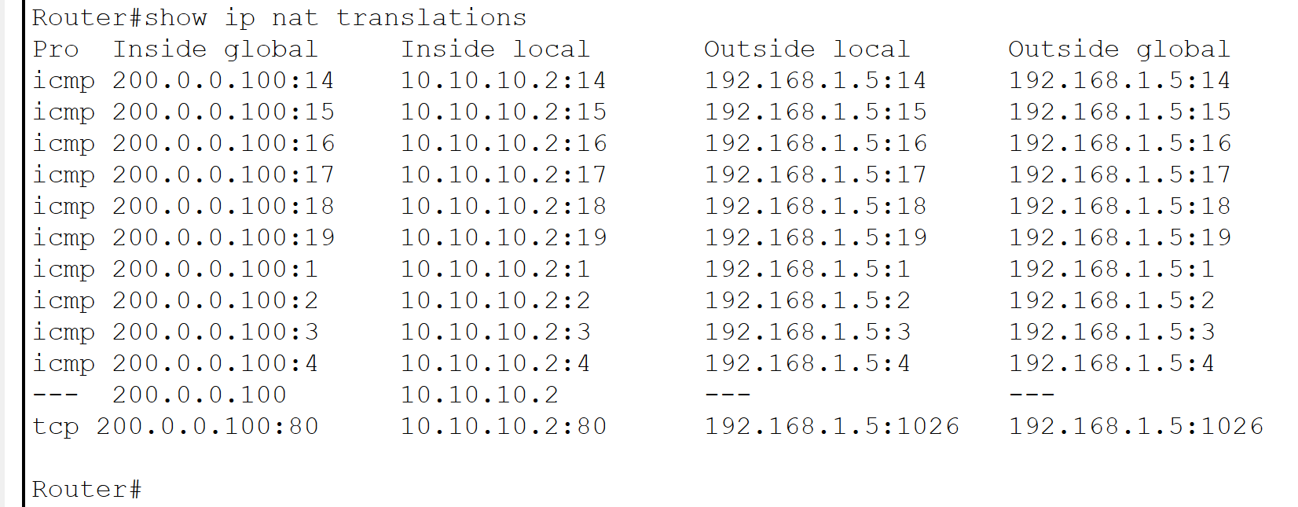

8. VPN status + successful ping

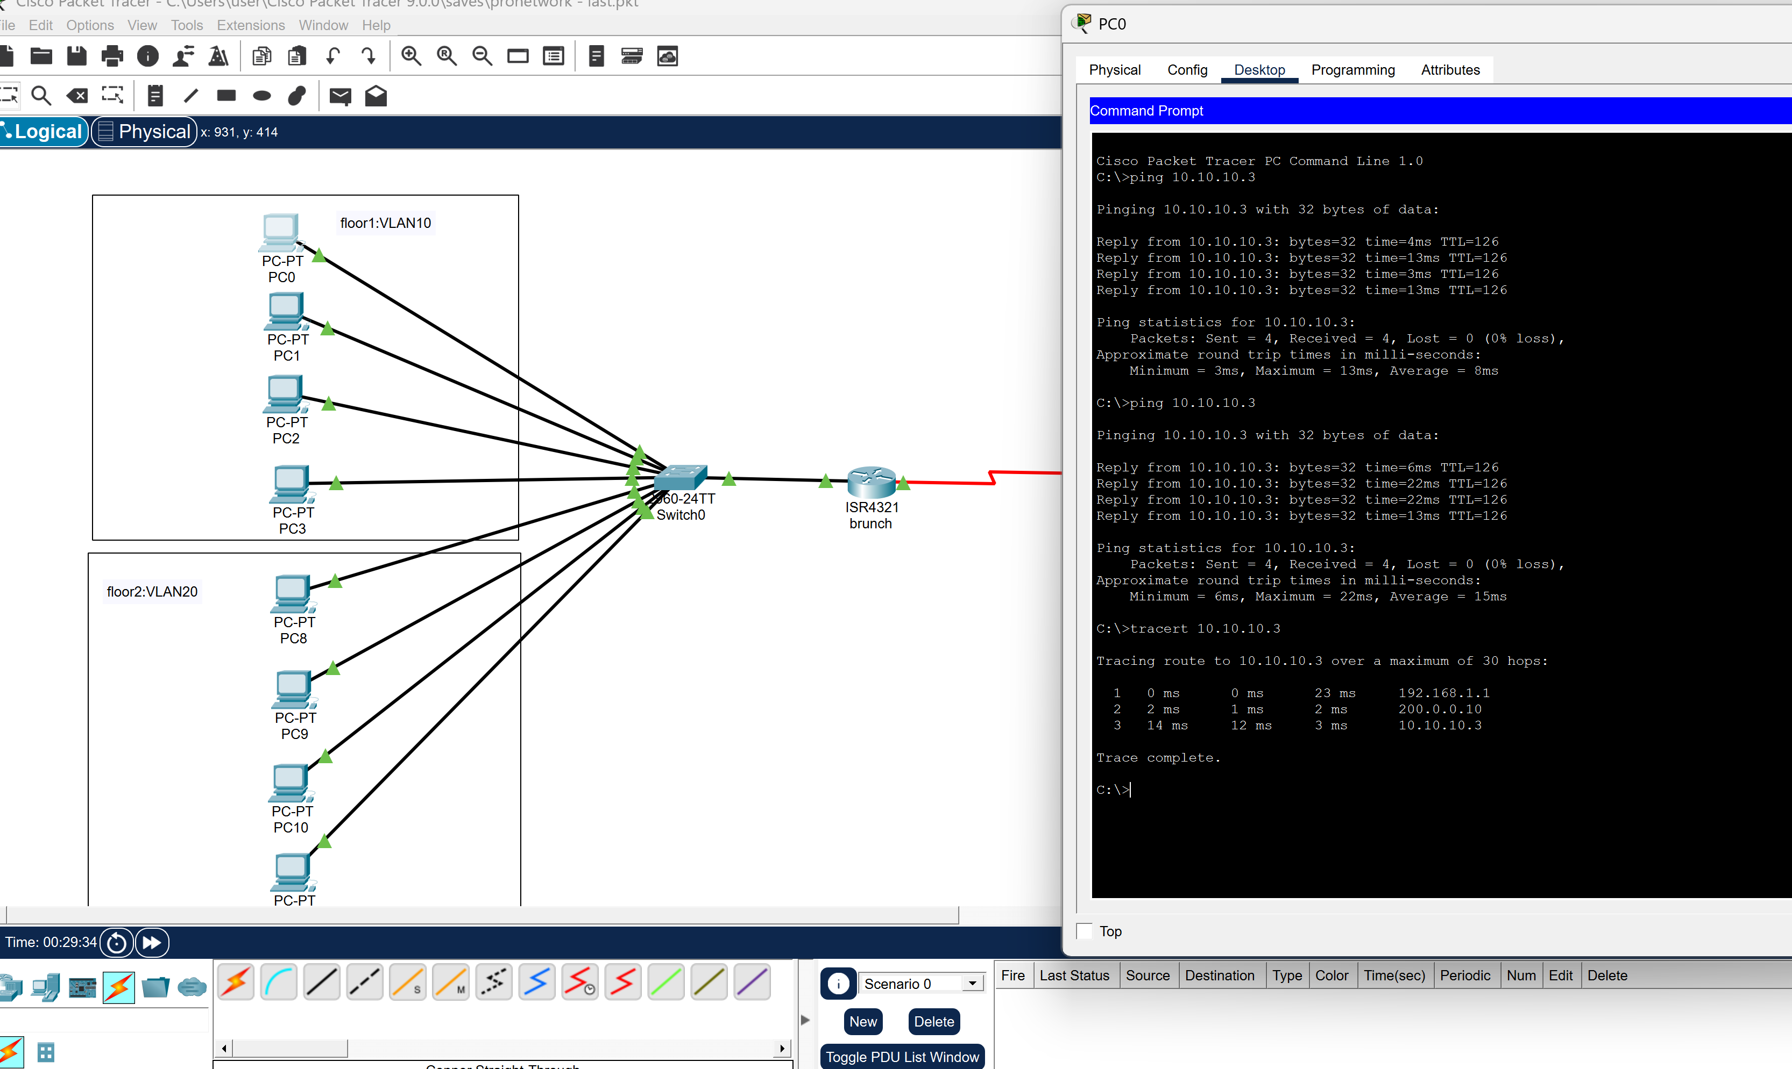
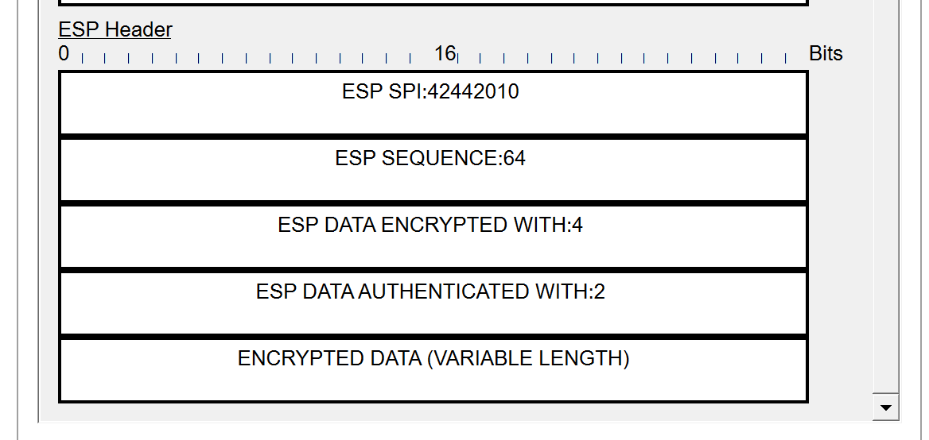
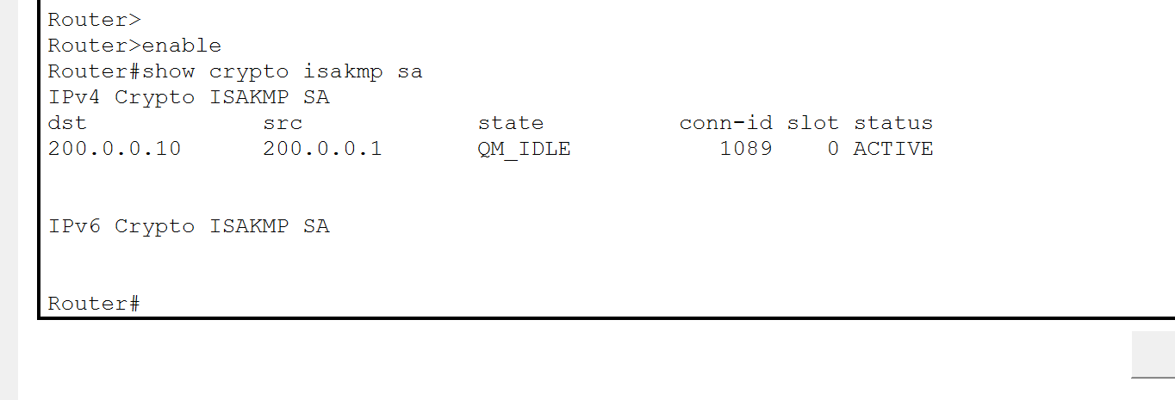
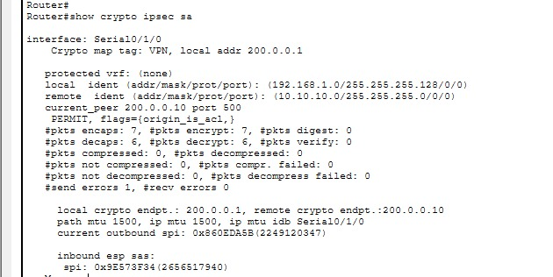

9. Routing table from each router

Branch:
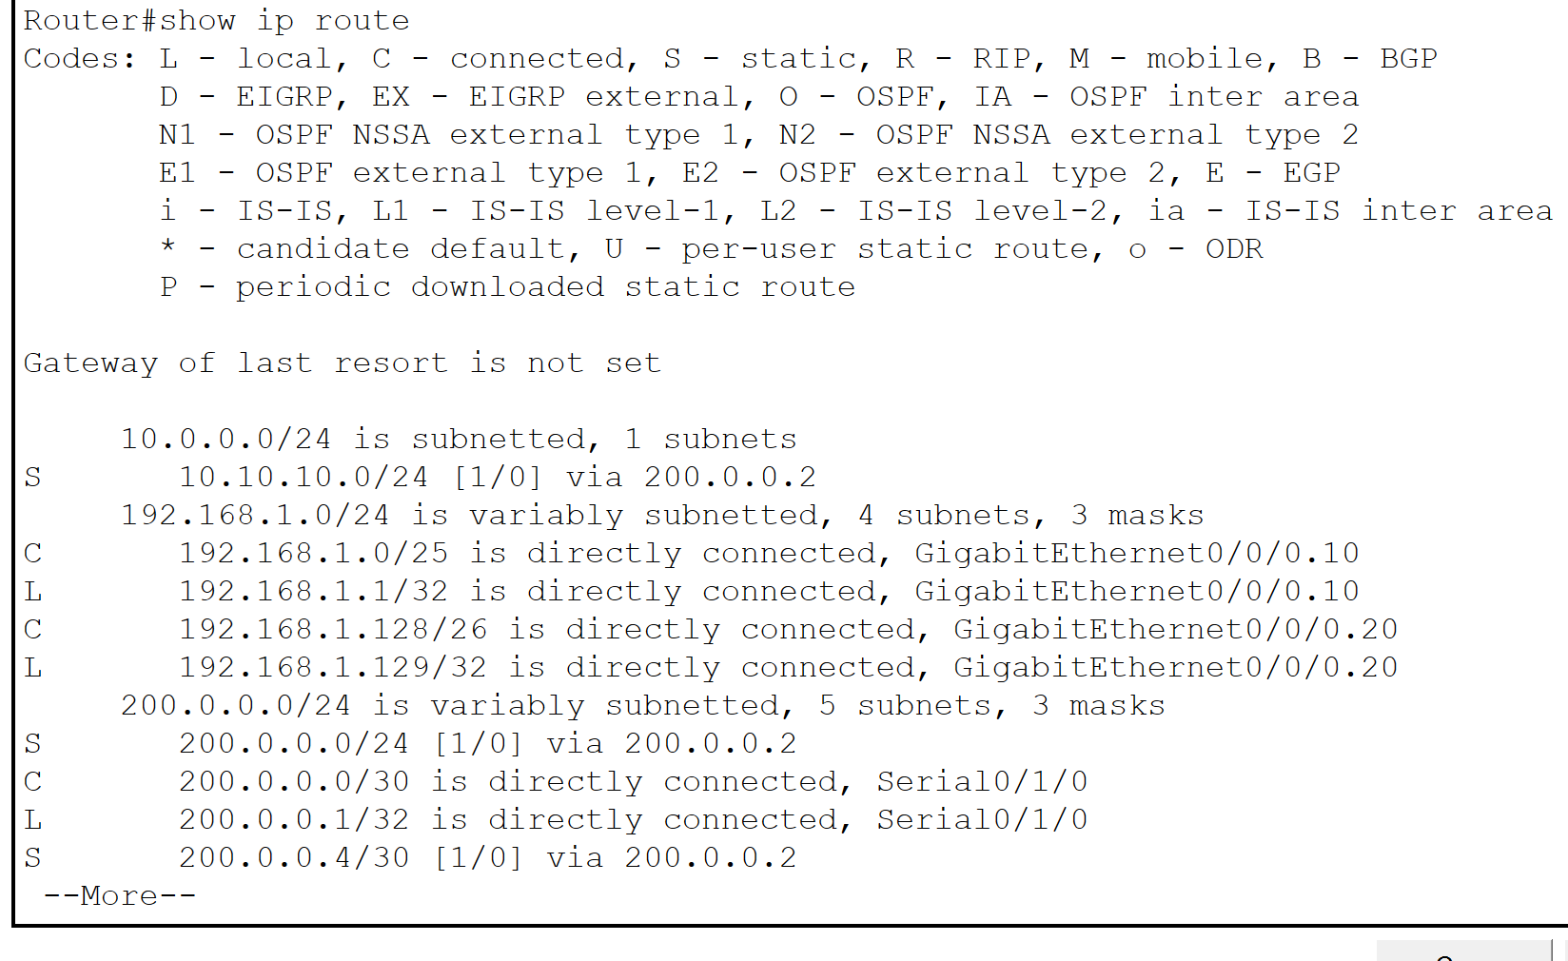

RH HUP:
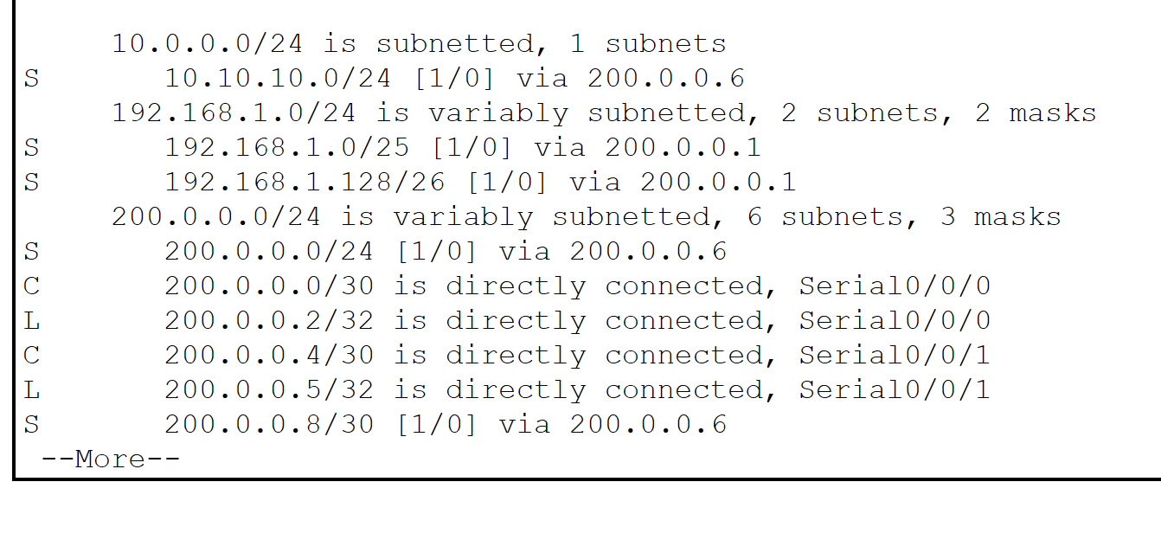

ISP:
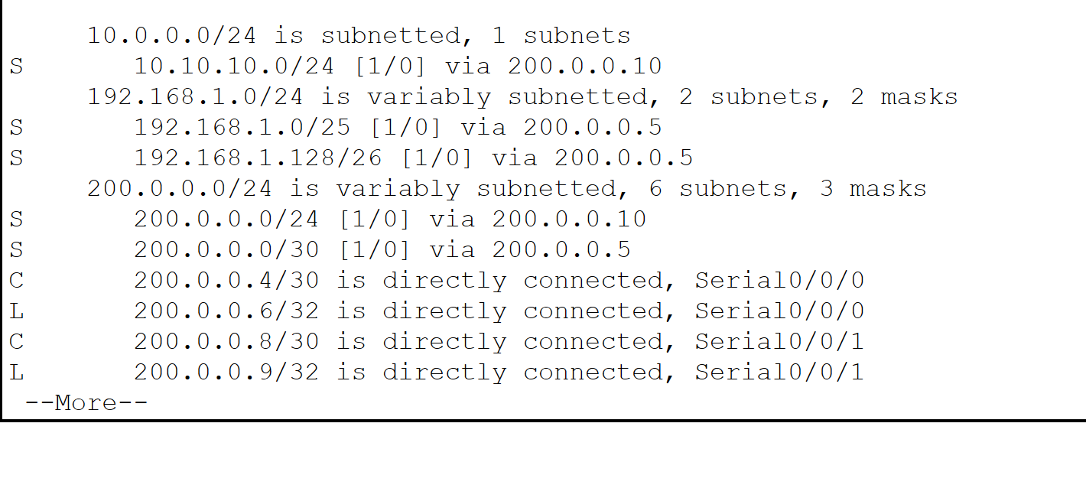

Cloud:
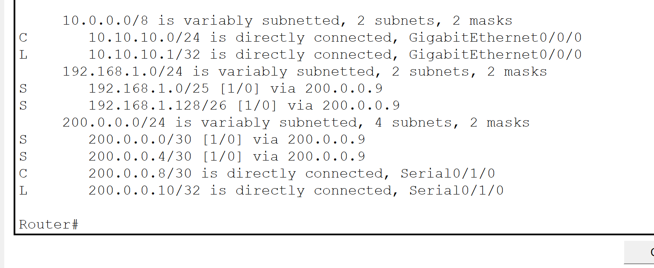

11. Web page opened in browser

12. Successful ping + simulation mode scenarios

